**ICP2 Report**

**Name : Harika Gurram**

**Class Id : 17**

**1.Write a program, which reads weights (lbs.) of Nstudents into a list and convert these weights to kilograms in a separate list using:1) Loops and2) List comprehensionsN: No of students (Read input from user)**

**Code:**

Here, I have taken two empty lists and by using for loop, I have taken input weights in lbs from user and appended in lst_lbs list and post converting lbs to kgs , appended the respective kgs values into lst_kgs list.

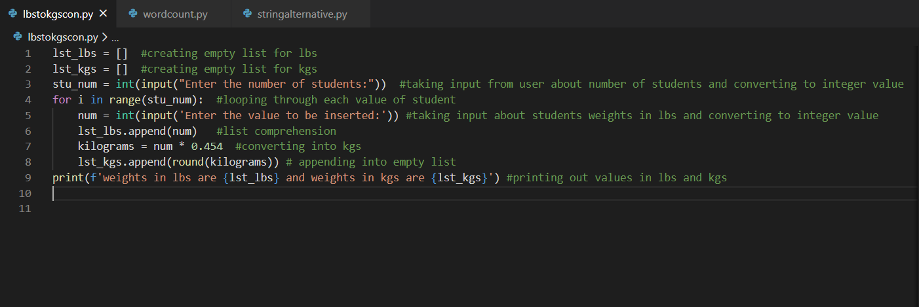

**Output:**

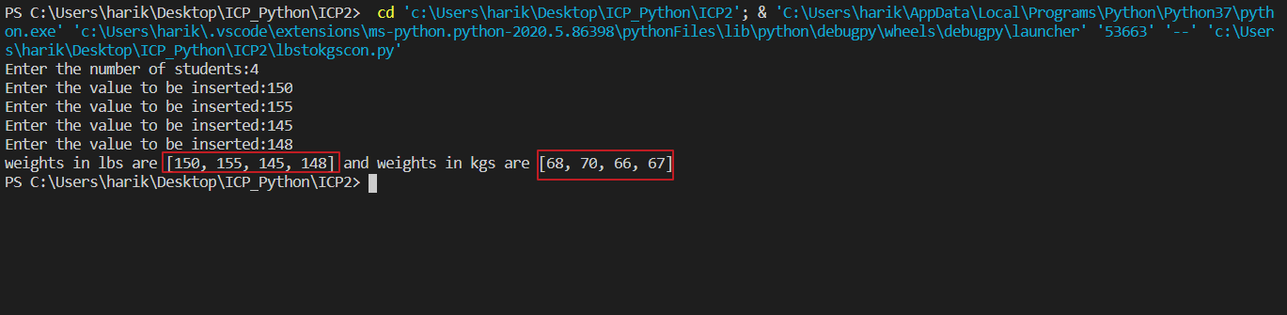

**2.** **Write a program that returns every other char of a given string starting with first using a function named “string_alternative”**

**Code:**

Here, I have created one subfunction string_alternative which takes string input and performed index slicing by step 2 [::2] (returns each alternate char in string)

And, called the subfunction from the main function.

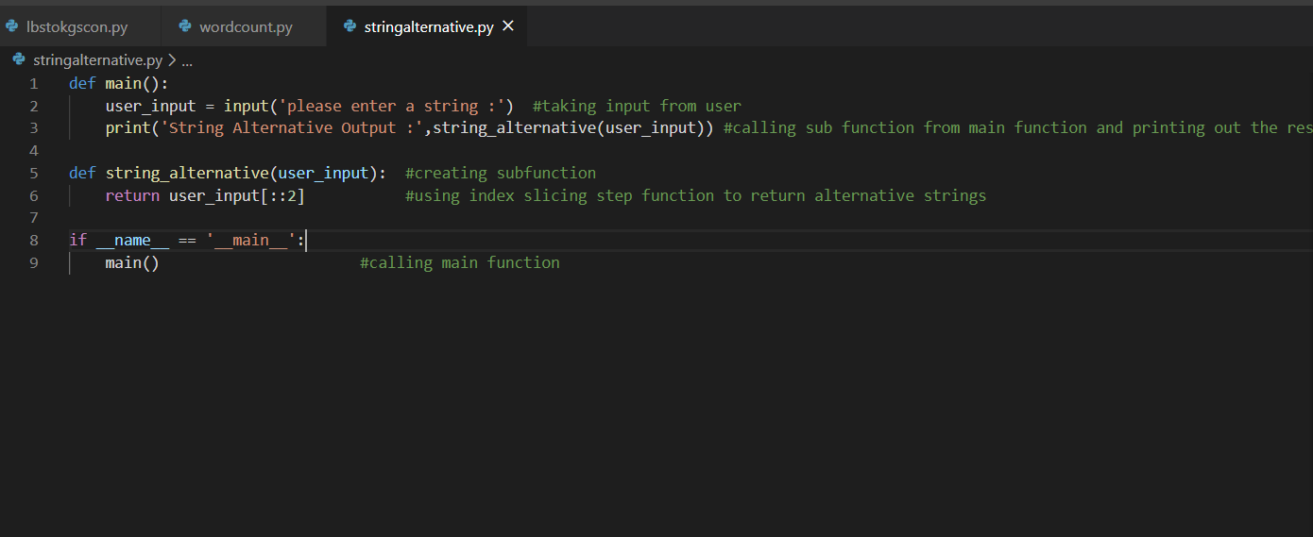

**Output:**

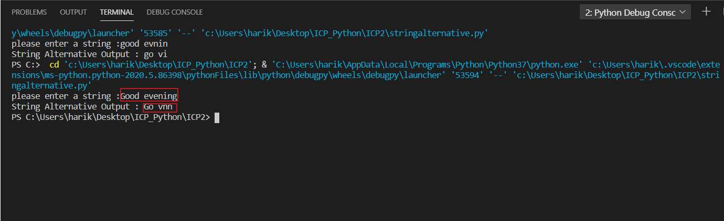

**3. Write a python program to find the wordcount in a file for each line and then print the output. Finally store the output back to the file.**

**Code:**

Here, I have created a text file and given data ‘python course and deep learning course’.

I have opened a text file in read mode, created an empty dictionary and split the data.

If the spiltted word doesn’t exist in keys of dict, I am storing value as 1 if word exists I am increasing the count.

And writing the output into the same file and closing it.

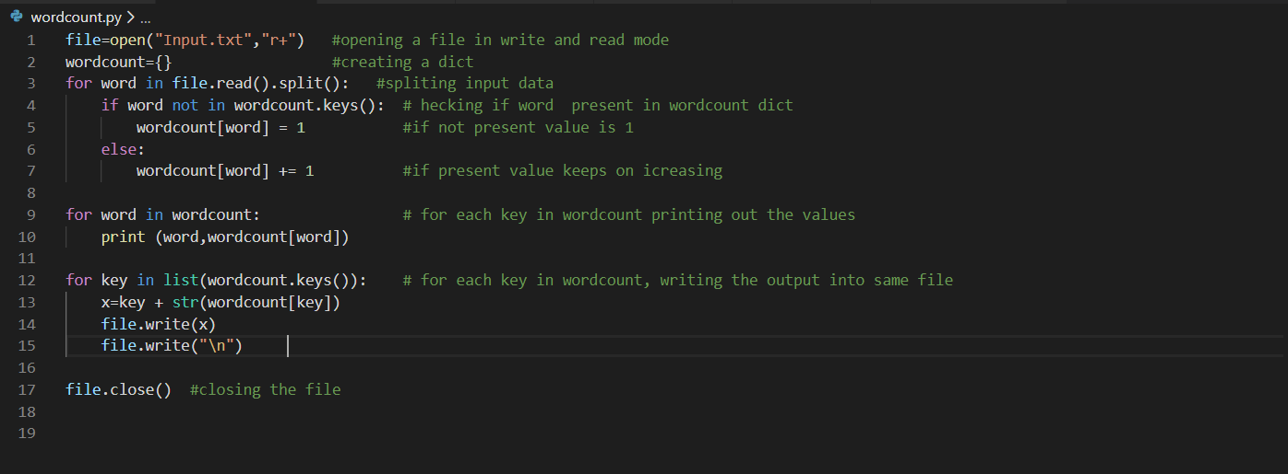

**Output:**

